August 2021

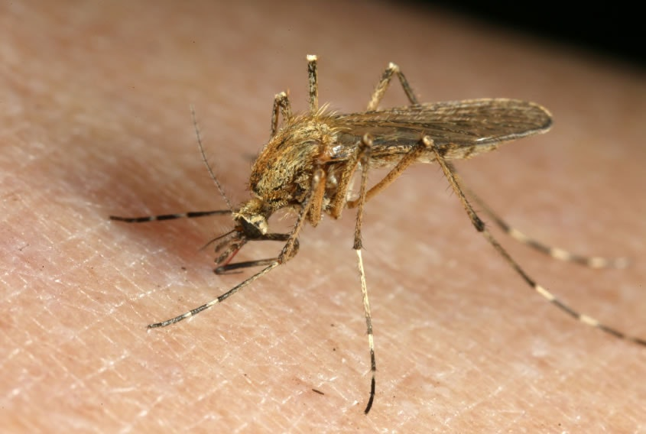

The West Millard mosquito Abatement District would like to address some of the natural questions about mosquito control this year. We are very aware of the increased number of mosquitoes over the last few weeks as opposed to other years.

People have asked us why the mosquitoes are so prevalent on this very dry year in and around Delta City. This has been a learning time for the District as well. A good mosquito year has become problematic as the summer progresses.

We have several species of mosquitoes in the area. Currently, the mosquitoes that are the problem are those that deposit their eggs in the vegetation and mud as the water recedes. This same mosquito travels up to twenty miles to find a blood meal to reproduce. These eggs can lay dormant for many years. As the water levels increase, the eggs hatch and the mosquito begins its life in the water. Within seven days, an adult mosquito is seeking blood.

Over the years the Gunnison Bend Reservoir has fluctuated little as compared to this year. We believe this fluctuation results from the repairs on the DMAD Reservoir. Every time the water in the Gunnison Bend Reservoir fluctuates, this hatches more of these mosquitoes in the river between Gunnison Bend and the DMAD. This is all within very close proximity to Delta City.

Most of the mosquitoes we kill are in the water. The District has tried to catch these water fluctuations as they occur, but there are just too many occurrences, and the terrain is difficult to navigate. This has happened between DMAD and Lynndyl for years, but not much this year. Over the years we have learned how to navigate the river north of DMAD and have had some good success in controlling the mosquitoes.

Every year we have realized that the summer thunderstorms spike the mosquito populations in the area.

Because of the bees and the chemical labels, the District has ruled out aerial application of pesticides along the river for adult mosquitoes. We are considering aerial treatment for the larvae in the water, but the vegetation in much of this area is so dense we do not believe the treatment would be effective. The chemical would never make it to the water. Presently, we treat as much of this area with our machines and by hand as we can. We do not expect this to be a big problem in future years as the irrigation companies complete the work on the DMAD.

There has been speculation about the District’s Budget. The District has a good budget. Over the last few years, mainly because of the drier conditions, we have been able to upgrade our equipment and buildings.

We have received a lot of concern about the ULV aerosol generators, commonly called foggers. The foggers have been upgraded as well. They are not nearly as loud as the older foggers we have used in the past. Perhaps, because they are quieter, people don’t seem to recognize that we have been in the area. The foggers are equipped with GPS capabilities. The GPS turns the chemical application up or down according to the speed of the vehicle. The amount of chemical used is the same per acre when the vehicle is traveling 3 miles per hour or 15 miles per hour. Often, this year we have received calls from angry constituents asking why they are never getting treatments. As we check our GPS records, we have found that the fogger has been at the location many times in the last few weeks and even the night before. Once the mosquitoes have become adults, it is very difficult to kill them all with a fogger, because they disperse so quickly. When conditions are perfect, which is rarely the case, only the mosquitoes on the downwind side of the prevailing wind will be treated with a fogger. If it is a windy evening, we cannot work. It may take a sustained effort over many days to control a bad infestation of mosquitoes. It is important to recognize that there are legal restrictions on how often and how many times a location can be treated as well.

We must have evidence of mosquitoes before we can send the foggers out. We have over one hundred locations where we trap mosquitoes. Our District does more trapping than any of the districts in the state of Utah. We must have this information to justify the chemical treatments. The traps help us to identify and test the mosquitoes for West Nile Virus, Western Equine Encephalitis, and St. Louis Encephalitis. Also, if our constituents call for a request for service, this also justifies the use of the fogger.

Please call the District when you have a problem. If no one answers, leave a message. If you wish someone to return your call, please clearly leave your phone number and request us to call you.

We are doing our best in an unfortunate time. Many of us have become used to not having to use repellants. Please remember to protect yourselves when you can.

West Millard Mosquito Abatement District

Office Phone Number (435-864-4742)